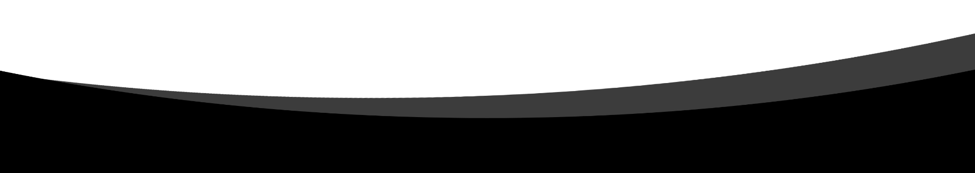

Project Name: Electric Blender

Project ID: **PO2_EBL**

Version: **1.1**

Project Status: **Proposed**

CYRS

Document

**Document History**

|  |  |  |  |
| --- | --- | --- | --- |
| Version | Author | Date | Change description |
| 1.0 | Mohamed Adel Anis | 22/01/2020 | Initial Creation of CYRS   * Creating two sections in document [Overall Description & Project Description] * **Overall Description section** contains general information about the project. * **Project Description section** contains detailed information about the system requirement. |
| 1.1 | Fatima Gomaa  Mohamed Adel Anis | 04/02/2020 | Updating the document according to the review of version 1.0   * **Re-arranging** the position of Document   history table and documents info.   * **Abstracting** requirements from the level of SW to be in System level prospective. * **Adding** Reference table at the end of the documents. |

Table of Contents

1. Introduction 3

1.1. Purpose 3

1.2. Document Structure 3

2. General Description 4

2.1 Project Description 4

2.2 Block Diagram 4

3. System Requirements 5

4. Reference Table 6

Table of Figures

Figure 1 -System Block Diagram 4

# Introduction

# Purpose

This is Customer requirement specification document (CYRS) for the KENOVO – Electric Blender project.

The purpose of CYRS is to describe the requirements of the client in more technical terms.

CYRS contains:

* Overall description of the customer requirements of the product.
* Functional analysis of the system requirements.

# Document Structure

This document is organized as follows:

* Section 1: Introduction to identify the document.
* Section2: Overall description about the system and information about it.
* Section 3: Requirements of the customer listed in more technical details.

# General Description

# Project Description

The goal of this project is to create an Electric blender that customer can change its rotating speed to three different levels of speed using only one button. The operating voltage should be monitored to detect any failure in the system.

# Block Diagram

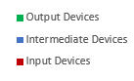Red: Input Devices
Blue: Intermediate devices 
Green: Output Device

Figure 1 -System Block Diagram

# System Requirements

Req_ PO2_EBL_Electric_Blender_CYRS_001-1.0 Imp#SW

{

The blender is operated with three main speeds.

}

Req_ PO2_EBL_Electric_Blender_CYRS_002-1.0 Imp#SW&HW

{

The blender should have push button to control the blender status and speed in which the sequence of the blender states is as following:

Turned OFF 🡪 Speed 1 🡪 Speed 2 🡪 Speed 3 🡪Turned OFF

}

Req_ PO2_EBL_Electric_Blender_CYRS_003-1.0 Imp#SW&HW

{

The system should monitor and detect any changes in the input voltage level of the electric blender’s electricity source.

}

|  |  |  |
| --- | --- | --- |
| Document | Version | Author |
| CRS | 1.0 | KENOVO |
|  |  |  |

# Reference Table